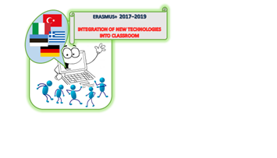

2nd transnational teaching / learning activity / training activity and short term exchange of students of the project “Integration of New Technology into Classroom“(2017-KA219-65)
Tamsalu, Estonia 15–21 April 2018
Using online tools to create quizzes; programs and apps in the Maths classroom
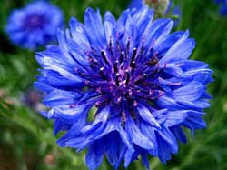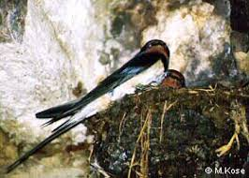

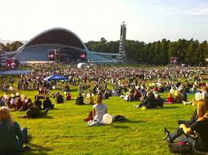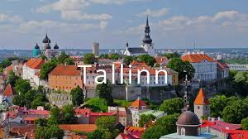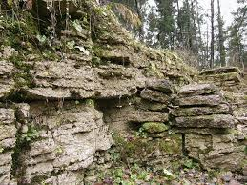

PROGRAMME
SATURDAY, 14 APRIL
Turkey: arrival at 17.20
bus to Tamsalu , accommodation at the sports centre

SUNDAY, 15 APRIL

Greece, Italy − bus to Tamsalu at 14.30
Germany − in the afternoon
Accommodation at the sports centre
Dinner at the sports centre 20.00

TURKEY: breakfast − 9.00
KEIMO, RENE, KARMEN, KENTEN, MÄRT - 10.00 sports centre!!!!! A tour of Tamsalu ( Mai will join you)
lunch – 14.00

MONDAY, 16 APRIL
TIME | ACTIVITY | Remarks
8.00–8.45 | Breakfast at the sports centre
9.00–10.30 | Welcoming meeting  Coffee and snacks | - getting acquainted with the school and students  - introduction to the programme and plans for the week
10.30–13.00 | Sightseeing in Tamsalu and Porkuni
13.00–14.00 | Lunch at school
14.00–15.30 | TRAINING AND LEARNING ACTIVITIES: GROUP WORK | - getting to know each group member  - students form 5 transnational groups as there are five students participating from each country  Each group has a teacher (1 per country) as group leader. Other teachers also help students during group work.  Each student and teacher has 5 minutes to introduce themselves and answer questions.  The groups put together a group picture to introduce themselves to other groups.
 |  | Mentimeter about Maths – individually
- play Kahoot – 10 questions: 2–5 for country mathematics
(play in groups)
15.30–15.45 | Coffee break
15.45–16.45 | TRAINING AND LEARNING ACTIVITIES: MATHS QUIZZES | - play Quizizz (Think out / 5 questions) play in groups  - play GoPollock (5 maths questions) in groups
16.45–17.00 | Coffee break
17.00–17.40 | TRAINING AND LEARNING ACTIVITIES: MATHS QUIZZES | - play Socrative (5 maths questions) in groups  - vote for the best quizzes app in Tricider
18.00–18.45 | Dinner at the sports centre
19.00–… | Icebreaking activities (games, etc)

TUESDAY, 17 APRIL
TIME | ACTIVITY | Remarks
8.00–8.30 | Breakfast at the sports centre
9.00–… | Sightseeing in Lääne-Viru county | Käsmu captains’ village, Vihula,  Palmse and Sagadi manors
14.00–15.00 | Lunch at Viitna Tavern –Estonian cuisine
…–19.00 | Sightseeing in Lääne-Viru county | Käsmu captains’ village, Vihula,  Palmse and Sagadi manors
20.00–20.30 | Dinner at the sports centre
21.00–… | Dance, zumba

WEDNESDAY, 18 APRIL
TIME | ACTIVITY | Remarks
8.00–8.45 | Breakfast at the sports centre
9.00–10.30 | TRAINING AND LEARNING ACTIVITIES:  MATHS LESSONS 1 | PowToon presentations (2 countries)
10.30–11.00 | Coffee break  Presentation of the robotics team
11.00–13.00 | 11.00-13.30 TRAINING AND LEARNING ACTIVITIES:  MATHS LESSONS 2 | PowToon presentations (3 countries)
13.00–14.00 | Lunch at school
14.00–15.30 | TRAINING AND LEARNING ACTIVITIES:  MATHS QUIZZES | - play Nearpod  - short introduction of all apps
15.30–15.45 | Coffee break
15.45–16.45 | TRAINING AND LEARNING ACTIVITIES:  MATHS WORKSHOP 1 | - drawing the quiz app for each group  - drawing the lessons for each group
16.45–17.00 | Coffee break
17.00–18.00 | TRAINING AND LEARNING ACTIVITIES:  MATHS WORKSHOP 1 continued | - groups familiarizing with the app  - watch the lessons again
18.00–18.45 | Dinner at the sports centre
19.30–… | Water aerobics at the sports centre | NB! snacks (fruit etc.) available afterwards

THURSDAY, 19 APRIL
TIME | ACTIVITY | Remarks
8.00–8.45 | Breakfast at the sports centre
9.00–10.30 | TRAINING AND LEARNING ACTIVITIES:  MATHS Workshop 2 | Students begin to create quizzes in groups.
10.30–11.00 | Coffee break
11.00–13.00 | TRAINING AND LEARNING ACTIVITIES:  MATHS Workshop 2 continued | Students create quizzes.
13.00–13.40 | Lunch at school
13.40–15.00 | TRAINING AND LEARNING ACTIVITIES:  MATHS Workshop 3 | Students create quizzes.
15.00–15.20 | Coffee break
15.20–16.45 | TRAINING AND LEARNING ACTIVITIES:  MATHS GAME | Each group will test their quizzes in group.  - Alternative for the early finishes: DESMOS-POLYGRATH individually for developing maths terminology
17.00–19.00 | A visit to Oruveski farm
19.00–19.30 | Dinner at the sports centre
20.00–… | Sports activities at the sports centre. / Teachers’ meeting.

FRIDAY, 20 APRIL
TIME | ACTIVITY | Remarks
8.00–8.45 | Breakfast at the sports centre
9.00–10.30 | TRAINING AND LEARNING ACTIVITIES: Finalising the mini-lessons with quizzes  Presentation of the mini-lessons | Each group will test their quizzes in group.  Each group will discuss after the quiz:  - How did your group work go? Did everyone have role?  - What are the advantages and disadvantages of the app?  - What is your opinion about the app/program? Do you think it would make learning easier?  Students who answered the quiz evaluate this using Tricider individually.
10.30–11.00 | Coffee break
11.00–13.00 | TRAINING AND LEARNING ACTIVITIES:  Presentation of the mini-lessons with quizzes  EVALUATION OF THE PROJECT ACTIVITIES (EVALUATION FORMS, PARTICIPANT LISTS,  SIGNATURE LISTS)  PROJECT MEETING FOR TEACHERS | … continued  Teachers discuss the results of the project week, interim report and plan the next meeting in Karditsa.
13.00–13.40 | Lunch at school
14.00–19.00 | A trip to Rakvere and Rakvere Castle. Shopping for souvenirs.
20.00–… | FINAL EVENING (CERTIFICATES)

SATURDAY, 21 APRIL
3.00 Leaving for the airport (packed breakfast) - Greece
9.00 Breakfast at the sports centre - Turkey, Germany, Italy
14.00 Departure for Tallinn – Turkey, Italy

